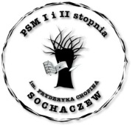
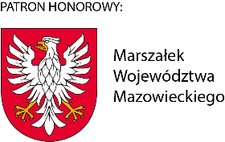
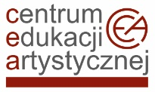



Festival subsidised by the Centre for Artistic Education

Centre for Artistic Education

The Fryderyk Chopin State Music School in Sochaczew

Association of Friends of the Fryderyk Chopin State Music School

in Sochaczew

XXXII INTERNATIONAL CHOPIN FESTIVAL IN MAZOVIA
SOCHACZEW
20-23 November 2024.

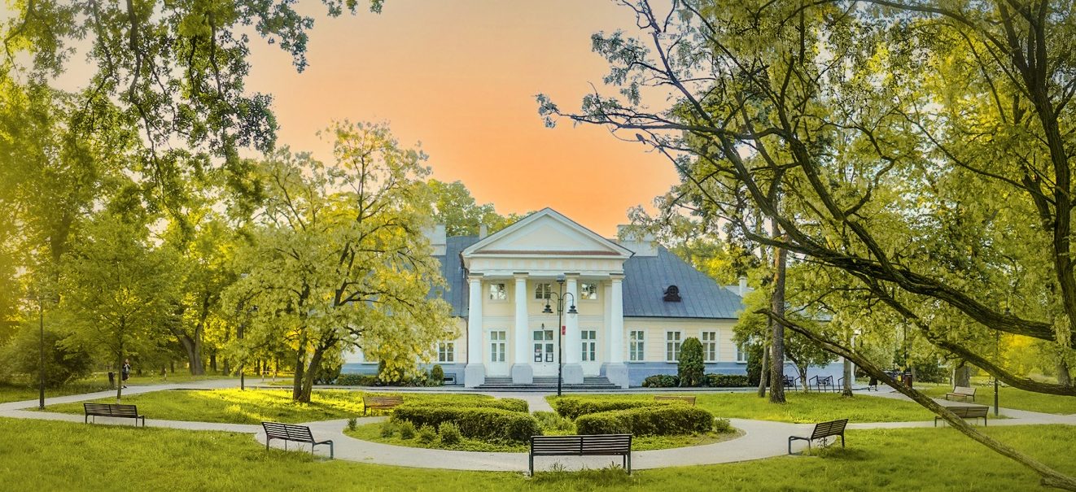

Jury Members of the XXXII International Chopin Festival in Mazovia
in alphabetical order:

Dorian Leljak Serbia – Croatia
Joanna Ławrynowicz-Just Poland
Karol Radziwonowicz Poland – Chairman of the Jury
Wojciech Świtała Poland
Irene Veneziano Italy

The organizers of the XXXII International Chopin Festival in Mazovia are:

Centre for Artistic Education

The Fryderyk Chopin State Music School in Sochaczew

Association of Friends of the Fryderyk Chopin State Music School in Sochaczew

We want to give the young artists an opportunity to appear on the stage of our School, located near the Birth Place of Fryderyk Chopin in Żelazowa Wola – a place revered by the entire world.

SCHEDULE

20 of November 9.00 a.m.
THE OPENING CEREMONY OF THE XXXII INTERNATIONAL
CHOPIN FESTIVAL IN MAZOVIA

CONCERT HALL

- 20.11.2024 (Wednesday) 9.30 a.m. participants’ public auditions
18.00 p.m. Gala Concert by Members of the Jury

- 21.11.2024 (Thursday) 9.30 a.m. participants’ public auditions

- 22.11.2024 (Friday) 9.30 a.m. participants’ public auditions

5.00 p.m. announcement of results, meeting of the Jurors with participants and their teachers

6.30 p.m. Awards ceremony and Concert of the
Prize-Winners
- 23.11. 2024 (Saturday) 12.00 a.m. Concert of the Prize-Winners in Frederic Chopin’s Birth Place in Żelazowa Wola

The Organizers reserve the right to change the schedule of the participants’ public performances depending on the number of applications

Festival coordinator: Aleksandra Hartman
e-mail: aleksandrahartman@psmsochaczew.pl

REGULATIONS
Each participant chooses a program from the following four repertoire ranges according to his level of proficiency
(without division into age groups).

Program should be performed from memory.

I repertoire range
One each of the following works by J.S. Bach and F. Chopin:

- J.S. Bach Minuet in C minor (French Suite in C minor)
Minuet in G major (Łatwe Utwory/Easy Works No. 1)
Prelude in D minor (Małe Preludia/Little Preludes No. 5)
- F. Chopin Polonaise in G minor
Polonaise in B flat major
Polonaise in A flat major

(A special prize to be awarded for the best performance of Polonaise in A flat major)

II repertoire range
One each of 2 groups of the following works by J.S. Bach and F. Chopin:

- J. S. Bach One of the Two- and Three-Part Inventions or

F. Chopin Fugue in A minor

(A special prize to be awarded for the best performance of Fugue in A minor)

- F. Chopin (Paderewski Edition)
Nocturne in C minor, Op. posth.; Nocturne in C sharp minor, Op. posth.;
Nocturne in E minor, Op. 72;
Mazurka in F major, Op. 68 No. 3; Mazurka in C sharp minor, Op. 6 No. 2;
Mazurka in B flat major, Op. posth. No. 56
Contredanse;
Waltz in A minor, Op. posth.; Waltz in E major, Op. posth.
(PWM edition, Two Forgotten Pieces)

III repertoire range

- J. S. Bach Prelude and Fugue from The Well-Tempered Clavier I or II (URTEXT)

- F. Chopin 2 different forms from the following:
Waltzes; Nocturnes; Mazurkas; Impromptus;
3 Ecossaises, Op. 72; Rondo in C minor, Op. 1; Etudes, Op. 10; Op. 25
3 Etudes for the “Méthode des Méthodes” (Trois Nouvelles Études)
Polonaises (excluding the 4 Great Polonaises)

IV repertoire range

1. J. S. Bach Prelude and Fugue from The Well-Tempered Clavier I or II (URTEXT)

2. F. Chopin 2 Etudes from Op. 10 or Op. 25

- F. Chopin One of the following works:
Ballades; Scherzos; Polonaises: A flat major, op. 53; F sharp minor, Op. 44; Tarantella, Op. 43; Bolero, Op. 19; Berceuse, Op. 57;
Variations brillantes, Op. 12 „Je vends des Scapulaires”

The International Jury will evaluate the participants’ performances on a scale from 1 to 25 pts, taking into consideration: artistic merit, sound aesthetics, stylistic compatibility, technical skills, as well as performance quality of the selected Repertoire.

- For every Repertoire, the Jury will choose the 1st, 2nd and 3rd place Prize-Winners, and will announce honourable mentions.
- The Prize-Winners shall be awarded at least 21 points; the honourable mentioned at least 20 points.
- The Jury chooses any number of honourable mentions.
- The Jury reserves the right not to select Prize-Winners or to announce ex-aequo awards.
- The Jury’s decisions shall be final and irrevocable.

The winners of the Festival receive the entitlements referred to in:
(a) Article 44zh of the Law of September 7, 1991 on the educational system (exemption from the promotional examination at the art school with the highest positive annual classification grade),
(b) Article 132 of the Law of December 14, 2016. - Education Law (priority admission to secondary schools),
(c) or regulations issued pursuant to Article 162 of the Law of December 14, 2016. - Education Law (the manner of converting individual criteria into points during the recruitment procedure to secondary schools).

- This year's Festival is financed by the Centre for Artistic Education.
- For participants from Poland, participation in the Festival is free of charge.
- Foreign participants are required to pay an entry fee of 50 Euros to the following bank account:
Państwowa Szkoła Muzyczna I i II stopnia w Sochaczewie
Numer of bank account:
PL 09 1010 1010 0101 0013 9134 0000
Swift NBPLPLPW
- Qualification of participants to the Festival is determined by the order of applications.
- Applications of participants for the XXXII International Chopin Festival in Mazovia will be accepted through an electronic online form made available from October 21 to November 8, 2024.
Applications for the competition must be submitted via the electronic form available on the school's website
https://www.gov.pl/web/psmsochaczew/miedzynarodowy-festiwal-chopinowski-na-mazowszu
The form must be accompanied by a scan of signed consents for the processing of personal data and permission to disseminate the image (the statement is attached as Appendix 1 to these regulations, or downloadable at:
https://www.gov.pl/web/psmsochaczew/miedzynarodowy-festiwal-chopinowski-na-mazowszu)
The original of the signed consents and permission must be handed over to the organizers immediately
on the day of the start of the Festival.

NOTE: failure to attach the above documents will result in inability to participate in
in this Festival.

Deadline for submission of applications - until 08.11.2024.

- All Festival Participants will receive Diplomas.
- The Prize-Winners will additionally receive Honourable Diplomas and material Awards.
- The repertoire of the Concert of Prize-Winners will be determined by the Jury.
- Participation in the Concert of Prize-Winners and in the concerts organized in Żelazowa Wola is obligatory.
- The Festival Participants along with their Pedagogues will have the possibility to consult the Festival Jury (please have your sheet music). The term of the Jurors consultations will be announced with additional schedule.
- The Jury will select the Prize-Winners having listened to the performances of all four repertoires.
- The list of participants qualified to participate in Public Performances, as well as the approximate performance schedule will be available on the following website: www.gov.pl/web/psmsochaczew (Konkursy i Festiwale).
- The rehearsals of the participants ought to be arranged by phone with the organizers:
+48 46 862 29 62.
- All participants should be at the Jury’s disposal one hour before their performance.
- The participants’ performances and the Concert of Prize-Winners may be streamed free of charge, and photographed for press purposes to promote the Festival.
- Participants shall cover the costs of travel to and stay in Sochaczew.
- Below is a list setting out some accommodation options for those who wish to stay overnight in Sochaczew or Teresin (nearby):
- Hotel „Chopin”: phone: +48 46 862 59 99, www.hotelchopin.pl
- Centrum Kształcenia Kadr in Teresin: phone +48 46 861 37 69,
www.ckk-teresin.pl/tanienoclegi.html
- Franciscan Monastery in Niepokalanów: phone: +48 46 864 2131

Administrator Information Clause concerning the processing of personal data:
In accordance with Article 13 para. 1 and para. 2 of the Regulation of the European Parliament and of the Council (EU) 2016/679 of 27 April 2016 on the protection of natural persons in regard to the processing of personal data and on the free movement of such data, and repealing Directive 95/46 /EC (General Data Protection Regulation — Official Journal of the European Union L.2016.119.1 of 4 May 2016), hereinafter referred to as "GDPR", please note the following:

- The Administrators of your personal data are the following entities:
- The Fryderyk Chopin State Music School in Sochaczew, ul. Głowackiego 2,
represented by its Principal.
Contact details: phone +48 695 345 359, email: dyrektor@psmsochaczew.pl
Data Protection Officer: https://psmsochaczew.pl/polityka-prywatnosci/ is the administrator of all personal data necessary for the preparation and conduct of the Festival.
- The Centre for Artistic Education, ul. Mikołaja Kopernika 36/40, 00-924 Warszawa, represented by its Director.
Contact details: phone +48 22 421 06 21, email: sekretariat@cea.art.pl
Data Protection Officer: https://cea art.pl/pracownicy cea/ is the administrator of all personal data necessary for the performance of the festival organizer’s tasks stipulated by the provisions of law, including those resulting from reporting of the executor to the organizer.

A list of other rights is available under the following link:
https://ceaart.pl/ochrona danych osobowych/

- The personal data and image voluntarily provided in the Application Form will be processed in accordance with Article 6(1)(a) of the RODO (consent of the data subject).
- Personal data will be processed for the purpose related to the conduct of the International Chopin Festival in Mazovia, in accordance with these competition regulations.
- Personal data will be processed on paper and electronically.
- Personal data will be kept for the period necessary for the competition, in accordance with the law on archiving (or until consent is revoked) and the terms and conditions of Facebook and YouTube.
- Personal data may be shared with recipients of data within the meaning of Article 4(9) of the RODO only within the limits of the law, e.g. with whom the administrator has signed data processing agreements on behalf of the controller.
- Personal data will not be subject to automated decision-making processes by the Administrator, including profiling.
- Anyone who has consented to the processing of personal data has the right to withdraw their consent at any time. Withdrawal of consent will not affect the lawfulness of processing that was carried out on the basis of consent before its withdrawal.
- Withdrawal of consent will have consequences of not being able to participate in the competition or its adjudication.
- Withdrawal of consent may take the following form: I withdraw my consent to the processing of personal data by ...., given on ... for the purpose of ... Signature of the person whose data are in question.
- Each data subject has the right to request access to, rectification, erasure or restriction of processing of personal data concerning him/her (if not restricted by the fulfillment of a legal provision).
- Any data subject has the right to lodge a complaint with a supervisory authority in accordance with Article 77 of the RODO (...any data subject has the right to lodge a complaint with a supervisory authority, (...) if he/she believes that the processing of personal data concerning him/her violates this Regulation) - Office for Personal Data Protection, 2 Stawki Street, 00-193 Warsaw, tel. 22 531-03-00, www.uodo.gov.pl.

Appendix No. 1 to the Regulations of the International Chopin Festival in Mazovia

Sochaczew, date…

1. PARENTAL CONSENTS AND STATEMENTS:

I hereby declare that I know and accept the terms and conditions of the International Chopin Festival in Mazovia as presented in the Rules and Regulations and agree to my daughter/son/ward's participation. At the same time I undertake to provide her/his care during the Competition.
……
(legible signature of parent/legal guardian)

2. CONSENT TO PROCESS PERSONAL DATA:

1) Having read the administrator's information, included in the Rules and Regulations of the International Chopin Festival in Mazovia, I give my consent to the processing of my personal data in accordance with Article 6(1)(a) of the RODO
……
(legible signature of parent/legal guardian)

2) I hereby give my consent to the processing of personal data necessary for the purpose of paying the entry fee (bank transfer) referred to in the Rules and Regulations of the International Chopin Festival in Mazovia, pursuant to Article 6(1)(a) of RODO1 by the Association of Friends of the State Music School in Sochaczew.
……
(legible signature of parent/legal guardian)
3) Pursuant to the provisions of Article 6(1)(a) of RODO1 in conjunction with Article 18(1)(6) of the Act of July 18, 2002 on Providing Services by Electronic Means (Journal of Laws 2020, item 344), I consent to the processing of my personal data (e-mail address from which consents and declarations were sent) in electronic form solely for the purpose of correspondence in connection with participation in the International Chopin Festival in Mazovia. (applies in the case of sending electronic consents by the persons making the statement - parents, legal guardians)
……
(legible signature of parent/legal guardian)

3. PERSONAL IMAGE RELEASE FORM
Pursuant to the provisions of Article 81(1) of the Act of February 4, 1994 on Copyright and Related Rights (Journal of Laws 2022, item 2509) and Article 6(1)(a) of the RODO1, I authorize the Administrator to disseminate the image of my child in traditional and electronic form along with identifying data (name, age, school) in regard to his/her participation in the International Chopin Festival in Mazovia, as well as sharing information about the Festival and reporting on its progress. The image may be distributed in the form of photographs, film footage, audio and video recordings with the possibility of framing, retouching and compositions recorded on any media. This permission includes all forms of publication, in particular, dissemination on the school and Festival website, the school's social media (Facebook and YouTube), Facebook profile of the City of Sochaczew, and in the local media and press.
……
(legible signature of parent/legal guardian)

___________________
1) RODO- Regulation (EU) 2016/679 of the European Parliament and of the Council of April 27, 2016 on the protection of natural persons with regard to the processing of personal data and on the free movement of such data and repealing Directive 95/46/EC (General Data Protection Regulation OJ. L. 2016.119.1 dated May 4, 2016, as amended).
2) https://pl-pl.facebook.com/legal/terms/update - the declarant assures the administrator that he is aware of the regulations and rules of use of Facebook
3) https://www.youtube.com/intl/pl/about/policies/#community-guidelines - declarant assures administrator of knowledge of YouTube security policies

Act of 7 September 1991 on the Educational System (Journal of Laws 220, item 1327), The Regulation of the Minister of Culture and National Heritage of 21 November 2019 on the organization and method of conduct of competitions for the students of public schools and artistic institutions (Journal of Laws 2019, item 2328), as amended.

